SPECIALTY SANDWICHES
THE RENAISSANCE
Silverglades Signature Walnut Grape Chicken Salad OR Silverglades Smoked Chicken Salad, Crisp Lettuce, Tomato, And Onion Served On A Flakey Croissant $8.25
LITTLE ITALY
Italian Capicola, Genoa Salami, Boar’s Head Picante Provolone, Crisp Lettuce, And Tomato Sprinkled With Oil & Vinegar
Served On Toasted Ciabatta Roll $8.99
LOUISIANA LIGHTNING
Boar’s Head Salsa Turkey, Pepper Jack Cheese, Hot Mustard, Red Onion, Salsa, And Crisp Lettuce Served On A
Toasted Long Roll $8.99
LAWYERS HERO
Thinly Sliced Pork Loin, Danish Havarti, Crisp Lettuce, And Apple Butter Served On A Kaiser Roll. Served Warm $7.99
CINCY GOBBLER
Silverglades Home Roasted Turkey, Cranberry Relish,
Smoked Applewood Cheddar, And Crisp Lettuce Served On Crusted White Bread $8.99
TUNA MELT
Silverglades Signature Tuna Salad And Swiss Cheese Served On Grilled Rye $8.49
THE GRACIE GREEN
Silverglades Home Baked Ham, Baby Swiss Cheese And Crisp Lettuce Served With Brusshetta Topping On A
Toasted Long Roll $8.49
SKINNY MINNIE
Boar’s Head Buffalo Chicken Breast, Tomato, Cucumber, And Low Fat Ranch Served On Whole Wheat Bread Or
Bagel $8.99
DERBY DELI
Silverglades Home Roasted Beef Top Round, Horseradish Cheddar, Crisp Lettuce, Onion, And Steak Sauce Served On
New York Rye $8.99
HAWAIIAN BAGEL
Silverglades Home Baked Ham, Melted Smoked Mozzarella, And Pineapple Ring Served On A Toasted Bagel. Served Warm $8.49
FINDLAY MARKET
Boar’s Head Smoked Braunschweiger, Onion, And Old Fashioned Yellow Mustard Served The Old Fashion Way On New York Rye $7.99
THE CUBAN
Sliced Pork Loin And Home Baked Ham With Imported Swiss
Cheese, Sliced Garlic Dill Pickle And Dijon Mustard
Served On Toasted Ciabatta Roll $8.99
CHIPOTLE CHICKEN
Boar’s Head Chipotle Chicken Breast, Boar’s Head Chipotle Gouda, Pico De Gallo And Lettuce On Toasted
Ciabatta Roll $8.99
THE NEW YORKER
Boar’s Head Thinly Sliced Corned Beef With Imported Swiss Cheese, Findlay Market Sauerkraut, And Thousand Island Dressing Served On New York Rye. Served Warm $11.49
TERIYAKI CHICKEN
Boar’s Head Teriyaki Chicken, Provolone, Onions, Mushrooms, Banana Peppers, And Teriyaki Glaze On A Long Roll. Served Open Faced And Warm $8.99
THE KELLEY DELI
Boar’s Head Seasoned Peppered Pastrami Served Hot With Swiss Cheese & Deli Mustard Served On New York Rye $12.95
BLT
Crisp Bacon, Crisp Lettuce, Crisp Tomato, And Mayonnaise Served On Choice Of Toast $8.99
BLACKENED TURKEY SUB
Boar’s Head Blackened Turkey, Boar’s Head 3 Peppercorn Colby Jack, Lettuce, Tomato, Onions, Banana Peppers, And Mayonnaise Served On A Toasted Long Roll $9.95
THE PARMA CAPRESE
Boar’s Head Italian Imported Prosciutto Topped With Fresh Mozzarella, Sprinkled With Chopped Basil, Accompanied By Hand Sliced Roma Tomatoes, Topped With A Balsamic Vinaigrette Dressing And Served On An Italian Baguette. $14.95

COMBO DEAL
Combo Any Specialty Sandwich, Panini, Wrap, Or Salad With Your Choice Of A Fresh Fruit Cup, Cottage Cheese Or A Bag Of Dirty Potato Chips & Your Choice Of A 24 oz. Coca-Cola Fountain Drink Or 20 oz. Dasani Water add $2.49
PANINIS
THE BOB-A-Q
Diced Grilled Chicken Breast, Tangy BBQ Sauce, And Smoked Applewood Cheddar Served On Herb Seasoned
Focaccia Bread $7.99
BETTER THAN PIZZA
Mozzarella Cheese, Sliced Pepperoni, Marinara, And A Blend Of Fresh Herbs Served On Seasoned Focaccia Bread $7.49
WRAPS
CURRY CHICKEN WRAP
Boar’s Head Curry Chicken, Pepper Jack Cheese, Hummus, Onion & Lettuce Served In A Wheat Tortilla Wrap $7.99
BLT WRAP
Smoked Bacon, Fresh Lettuce, Sliced Tomato, & Mayonnaise Served On Your Choice Of Tortilla Wrap $8.99
CHICKEN CAESAR WRAP
Diced Grilled Chicken, Parmesan Cheese, Lettuce, Bacon, And Caesar Dressing Served In A Flour Tortilla Wrap $7.99
TOMATO TURKEY WRAP
Boar’s Head Turkey, Imported Swiss Cheese, Sun Dried Tomato Mayonnaise And Lettuce Served In A Tomato Flour
Tortilla Wrap $7.99
VEGGIE WRAP
Fresh Hummus, Red Cabbage, Tomatoes, Cucumbers, Mixed Bell Peppers, Carrots, Lettuce, And Garden Vegetable Yogurt Cheese Served In A Wheat Tortilla Wrap $6.99
ANDOULLIE LOUIE WRAP
Andoullie Sausage, Sautéed Mushrooms, Pepper Jack Cheese, And Spicy Chipotle Mayo Served In A Flour Tortilla
Wrap $7.99
GREEK WRAP
Diced Grilled Chicken, Black Olives, Feta Cheese, Fresh Lettuce, Fresh Tomatoes, And Greek Dressing Served In A Flour Tortilla Wrap $7.99
SOUTH OF THE BORDER WRAP
Diced Grilled Chicken, Pepper Jack Cheese, Black Bean & Corn Relish, And Chopped Fresh Cilantro Salsa, Served In A Flour Tortilla Wrap $7.99
SALAD BAR “MADE TO ORDER”
Enjoy A Silverglades Signature Salad Or Create Your Own From Our Full Service Salad Bar. Served Monday - Friday.
Classic….$7.99 Taco….$8.99 Premium….$8.99
PIZZA
5 Minutes Or Less
5 Minutes Or Less
Try A Silverglades Signature Pizza Or Individually Craft Your Own $9.95
HOT “HOMEMADE” LUNCH
See Our Daily Specials & Soups Served Monday - Friday At
www.silvergladesdeli.com
OR
twitter.com/silverglades
DAILY LUNCH SPECIAL
Choose One Of Our “Homemade” Entrees, 2 Sides, And
24 oz. Fountain Drink $9.95
“HOMEMADE” SOUPS
12 oz. Cup….$4.49 16 oz. Bowl….$5.49
BOX LUNCHES “Best in Town”
Individual Lunch Box For Each Person. All Box Lunches Include An Overstuffed Deli Sandwich Of Turkey, Ham, Or Roast Beef, & Cheese, Or Chicken Salad, Or Tuna Salad. Kosher Pickle, Lettuce & Tomato On The Side. Pasta Or Potato Salad And Fruit Salad. Your Choice Of A “Homemade” Cookie (Triple Chocolate Chip Or Oatmeal Raisin Or Peanut Butter). Condiments And Utensils Included. (24 Hour Notice) $9.95
(Same Day Pricing = Less Than 24 Hour Notice) $11.95
With 20 oz. Bottled Soda Or Waters Add Market Price
Please Tell Us About Any Food Allergies
BREAKFAST “MADE TO ORDER”
(Served until 10:30am Monday - Friday)
“Homemade” Oatmeal Du Jour $2.99
Add Fruit / Cinnamon / Brown Sugar $3.49
Scrambled Egg And Cheese Served On A Toasted Bagel $4.25
Scrambled Egg, Ham, & Cheese Served On A Kaiser Roll $4.99
Bacon, Egg, & Cheese Wrap
With/Without Sautéed Mushrooms $4.49
2 Large Biscuits Smothered With Sausage Gravy $3.99
Sausage And Biscuit Sandwich (Add Cheese $.25) $2.25
P B & G Wrap
(Peanut Butter, Banana, Granola, Vanilla Yogurt) $3.49
Fresh Bagels $1.95
Add “Homemade” Plain Cream Cheese $3.99
Bagel, Cream Cheese, & Lox (Try with Capers & Onions) $8.95
Omelet Served With Your Choice Of: Onion, Green Pepper, Tomato, Mushroom, Bacon, Ham, Sausage, Cheese) $7.95
Add A Side Of Toast And Hash Browns $9.95
New York Style Muffins (5 Oz.) $2.50
BEVERAGES
Soft Drinks Iced Teas Milks
Bottled Waters Energy Drinks Juices
“FULL SERVICE” SMOOTHIES
Four Berry Blend Blueberry Banana Peach Pear
Strawberry Pina Colada Lemonade Mango
CARRY OUT
Nice Selection of Domestic and Imported Beers and Wines
SILVERGLADES SPECIALTIES
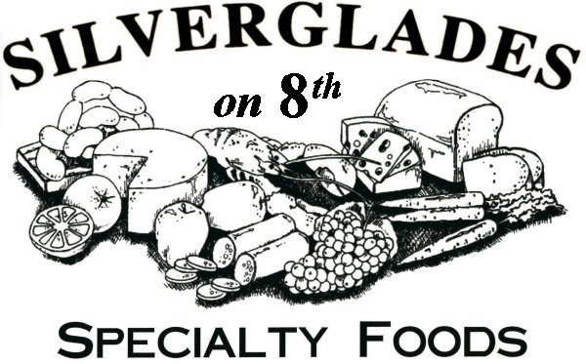
Premium Lunch Meats featuring Boar’s Head
Imported & Domestic Cheeses
Snacks for All Cravings
Cold Prepared Foods
Catering Available

CATERING AVAILABLE
Catering Menu Available In Store Or Online At www.silvergladesdeli.com


22025201

Prices & Menu Are Subject To Change Without Notice

In 1922, Al Silverglade, Sr. opened his stand at Findlay Market, and so began the “Silverglades” family business which has spanned three generations. At first, the business consisted of a small wooden stand made of saw horses, sheets of plywood covered with oil cloth, and two homemade glass cases that displayed cheeses and sausages. Rain or shine, Al Silverglade, Sr. set up his stand every Wednesday, Friday, and Saturday under the open-air façade of Findlay Market.
SILVERGLADES
Eight years later, Al Sr. and his wife, Grace, moved their business to stand No. 2 inside the Findlay Market building. This stand as well as 3 others purchased later by Al Silverglade, Jr., and his sons, Michael and Craig, still remains a vital part of the family business.
In our ongoing effort to bring quality products, friendly service, and our unique ambiance to other areas of Greater Cincinnati, we opened the doors in December 2001, we opened our doors to the Downtown cliental with our first store at 4th & Plum. With the increasing demand for our products and services in Downtown, we moved to our larger location at 8th & Sycamore in November 2003.
In 2011, the demand from our customers gave us the opportunity to add an additional 1000 square feet to our 8th & Sycamore location. We added a Full Service Salad Bar, more retail space and most importantly, extra seating.
With the help of our “Silverglades” family of employees, we are continuing the Silverglade family tradition of providing quality foods and excellent service to our customers. We appreciate your patronage and with our best effort we will continue to provide you with the finest foods and exceptional service available. If there is a particular product you wish to purchase but are unable to find it, please let us know and as always we will do our best to fulfill your request.
Thank You!
Al, Michael, & Craig
CINCINNATI
MAGAZINE
VOTED
BEST
Chicken
Salad

Special Requests Are Always Welcome
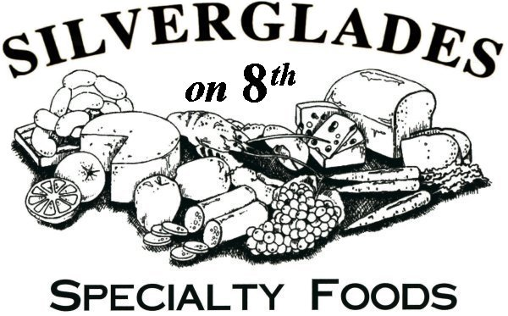

www.silvergladesdeli.com

MENU

Serving Breakfast, Hot Lunches, Sandwiches, Paninis, Wraps, Soups, Salads, & Pizzas Daily

Monday – Friday
7:30 am – 5:30 pm
Saturday
11:00 am – 4:00 pm

236 East 8th Street
Cincinnati, OH 45202
513-361-0600
Fax: 513-621-0400

Indoor Seating for 70+
& Sidewalk Dining
(Weather Permitting)

Text: BESTDELI to 33733
(Online Ordering App)

Prices & Menu Are Subject To Change Without Notice

